Bien, pues ahora vamos a centrarnos en el flujoa realizar en el traspaso y aplicación de los datos a inventor. Vamos a empazar de la forma mas sencilla:
Tenemos los siguientes archivos creados:
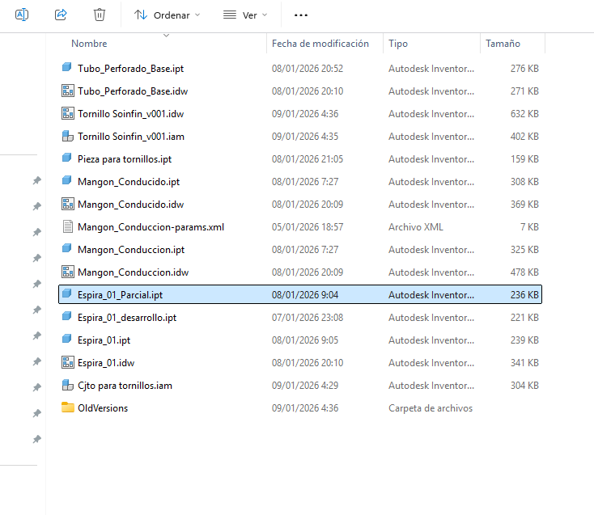

Las variables definidas en cada ipt son las siguientes:
En “Tubo_perforado_base.ipt”:
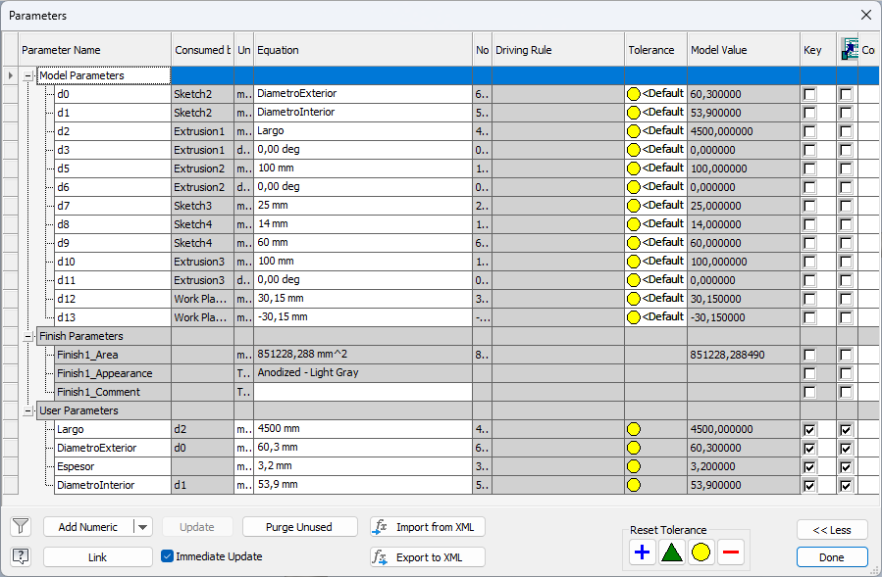
Y la regla iLogic “01_Validar_Tubo”: '=====================================================
' 01_Validar_Tubo
' Valida parámetros y mantiene coherencia geométrica
'=====================================================

'--- Leer parámetros (siempre con Parameter() para tener el valor actualizado)
Dim L As Double = Parameter("Largo") ' mm
Dim dExt As Double = Parameter("DiametroExterior") ' mm
Dim e As Double = Parameter("Espesor") ' mm

'--- Mínimos recomendados (ajústalos cuando quieras)
Dim Lmin As Double = 50 mm ' largo mínimo práctico
Dim emin As Double = 1 mm ' espesor mínimo

'--- Validación Largo

If L < Lmin Then
MessageBox.Show("Largo demasiado pequeño. Se ajustará a " & Lmin & ".", "Validación Tubo")
L = Lmin
End If

'--- Validación Espesor
If e < emin Then
MessageBox.Show("El espesor debe ser ≥ " & emin & ".", "Validación Tubo")
e = emin
End If

'--- Evitar diámetro interior negativo o cero
If (2 * e) >= dExt Then
MessageBox.Show("Espesor demasiado grande: el diámetro interior sería <= 0." _
& vbCrLf & "Se ajustará automáticamente.", "Validación Tubo")
e = dExt / 4
End If

'--- Escribir parámetros corregidos
Parameter("Largo") = L
Parameter("Espesor") = e
Parameter("DiametroInterior") = dExt - (2 * e)

'--- Actualizar modelo
InventorVb.DocumentUpdate()
Catch ex As Exception
MessageBox.Show("Error al actualizar el plano: " & ex.Message, "iLogic")
End Try

,y en su archivo de dibujo idw tenemos :

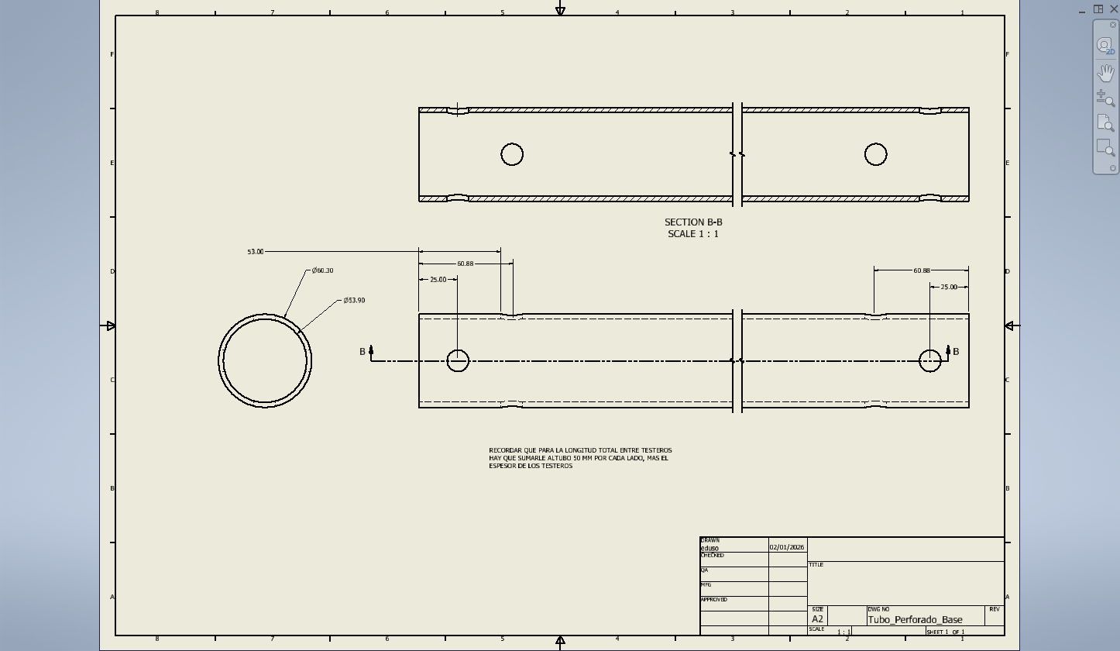
Y las reglas ilogic:
'========================================
' 01_Actualizar_Plano
' Actualiza el plano activo (y fuerza regen)
'========================================

Try
Dim oDoc As Inventor.DrawingDocument = ThisApplication.ActiveDocument

' Actualiza el documento
oDoc.Update()

' Fuerza actualización “fuerte” (si está disponible)
Try
ThisApplication.ActiveDocument.Update2(True)
Catch
' Algunas versiones/estados no soportan Update2 aquí, no pasa nada
End Try

Catch ex As Exception
MessageBox.Show("Error al actualizar el plano: " & ex.Message, "iLogic")
End Try
Y la regla:
'========================================
' 02_Exportar_PDF
' Exporta el plano activo a PDF (robusto)
'========================================

Function TryGetParamMM(ByVal refDoc As Inventor.Document, ByVal pName As String, ByVal ByRef valOut As Double) As Boolean
Try
Dim p As Inventor.Parameter = refDoc.ComponentDefinition.Parameters.Item(pName)
' Value está en cm en algunos contextos? En Inventor API suele estar en cm (dependiendo). Aquí asumimos unidades internas.
' Mejor: usar .Value y luego pasar a mm con UnitsOfMeasure.
Dim uom = refDoc.UnitsOfMeasure
valOut = uom.ConvertUnits(p.Value, uom.LengthUnits, Inventor.UnitsTypeEnum.kMillimeterLengthUnits)
Return True
Catch
Return False
End Try
End Function

Function TryGetParamUnitless(ByVal refDoc As Inventor.Document, ByVal pName As String, ByVal ByRef valOut As Double) As Boolean
Try
Dim p As Inventor.Parameter = refDoc.ComponentDefinition.Parameters.Item(pName)
valOut = p.Value
Return True
Catch
Return False
End Try
End Function

Try
Dim oDoc As Inventor.DrawingDocument = ThisApplication.ActiveDocument

'--- Carpeta destino
Dim outFolder As String = "C:\edusonros_projects\SINFINES_CONRAD\PDF\"
If Not System.IO.Directory.Exists(outFolder) Then
System.IO.Directory.CreateDirectory(outFolder)
End If

'--- Referenciado principal (mejor desde la primera vista del Sheet1 si existe)
Dim refDoc As Inventor.Document = Nothing
Try
Dim oSheet As Inventor.Sheet = oDoc.Sheets.Item(1)
If oSheet.DrawingViews.Count > 0 Then
refDoc = oSheet.DrawingViews.Item(1).ReferencedDocumentDescriptor.ReferencedDocument
End If
Catch
' fallback
End Try

If refDoc Is Nothing Then
' fallback: primer documento referenciado
refDoc = oDoc.ReferencedDocuments.Item(1)
End If

'--- Construir nombre PDF
Dim baseName As String = System.IO.Path.GetFileNameWithoutExtension(oDoc.FullFileName)

' Intenta leer parámetros habituales
Dim L As Double, DE As Double, DI As Double, E As Double, P As Double, N As Double
Dim hasL As Boolean = TryGetParamMM(refDoc, "Largo", L)
Dim hasDE As Boolean = TryGetParamMM(refDoc, "DiametroExterior", DE)
Dim hasDI As Boolean = TryGetParamMM(refDoc, "DiametroInterior", DI)
Dim hasE As Boolean = TryGetParamMM(refDoc, "Espesor", E)
Dim hasP As Boolean = TryGetParamMM(refDoc, "Paso_Espira_01", P) OrElse TryGetParamMM(refDoc, "Paso_Espira", P) OrElse TryGetParamMM(refDoc, "Paso_Esp", P)
Dim hasN As Boolean = TryGetParamUnitless(refDoc, "Num_Espiras", N) OrElse TryGetParamUnitless(refDoc, "Num_Vueltas", N)

Dim pdfName As String = baseName & ".pdf"

' Si hay datos, los metemos en el nombre
If hasL Or hasDE Or hasE Or hasP Or hasN Then
Dim parts As New List(Of String)

If hasDE Then parts.Add("DE" & CInt(Math.Round(DE)))
If hasDI Then parts.Add("DI" & CInt(Math.Round(DI)))
If hasE Then parts.Add("E" & CInt(Math.Round(E)))
If hasL Then parts.Add("L" & CInt(Math.Round(L)))
If hasP Then parts.Add("P" & CInt(Math.Round(P)))
If hasN Then parts.Add("N" & CInt(Math.Round(N)))

pdfName = baseName & "_" & String.Join("_", parts.ToArray()) & ".pdf"
End If

Dim pdfPath As String = System.IO.Path.Combine(outFolder, pdfName)

If System.IO.File.Exists(pdfPath) Then
Dim ts As String = DateTime.Now.ToString("yyyyMMdd_HHmmss")
pdfPath = System.IO.Path.Combine(outFolder, System.IO.Path.GetFileNameWithoutExtension(pdfName) & "_" & ts & ".pdf")
End If

'--- Actualizar antes de exportar
oDoc.Update()

'--- Traductor PDF
Dim oPDFAddIn As Inventor.ApplicationAddIn =
ThisApplication.ApplicationAddIns.ItemById("{0AC6FD96-2F4D-42CE-8BE0-8AEA580399E4}")

Dim oContext As Inventor.TranslationContext =
ThisApplication.TransientObjects.CreateTranslationContext()
oContext.Type = Inventor.IOMechanismEnum.kFileBrowseIOMechanism

Dim oOptions As Inventor.NameValueMap =
ThisApplication.TransientObjects.CreateNameValueMap()

If oPDFAddIn.HasSaveCopyAsOptions(oDoc, oContext, oOptions) Then
oOptions.Value("All_Color_AS_Black") = 1
oOptions.Value("Remove_Line_Weights") = 0
oOptions.Value("Vector_Resolution") = 400
oOptions.Value("Sheet_Range") = Inventor.PrintRangeEnum.kPrintAllSheets
End If

Dim oData As Inventor.DataMedium =
ThisApplication.TransientObjects.CreateDataMedium()
oData.FileName = pdfPath

oPDFAddIn.SaveCopyAs(oDoc, oContext, oOptions, oData)

Catch ex As Exception
MessageBox.Show("Error exportando PDF: " & ex.Message, "iLogic PDF")
End Try

Para la Espira del tornillo sinfín, tenemos 3 ipt y 1 idw, los cuales representan los siguebte:
“Espira_01_desarrollo.ipt”: Esta contiene el desarrollo practico del desarrollo para corte. Contiene los valores:
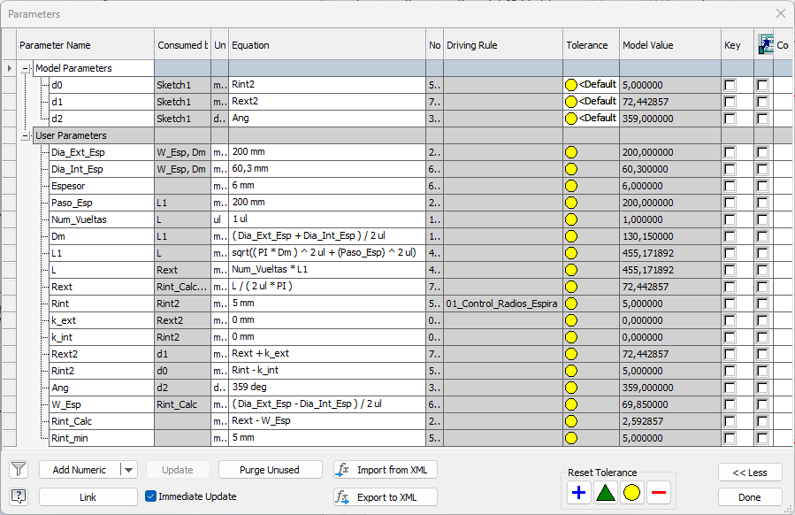

Y la regla:
'=========================================================
' 01_Control_Radios_Espira
' Fuerza radio interior mínimo para evitar geometrías inviables
'=========================================================

If Rint_calc < Rint_min Then
Rint = Rint_min
Else
Rint = Rint_calc
End If

Despues tenemos “Espira_01.ipt con las variables
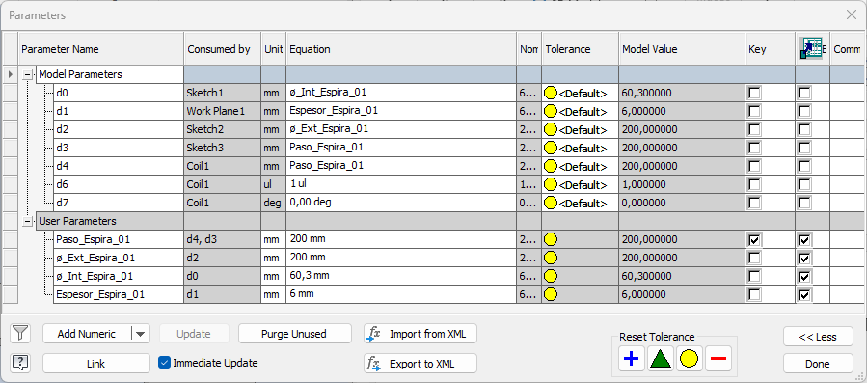
Y después tenemos “Espira_01_parcial.ipt” que ña utilizaremos para ajustar el numerp de espiras total en la longitud del tubo, con las variables
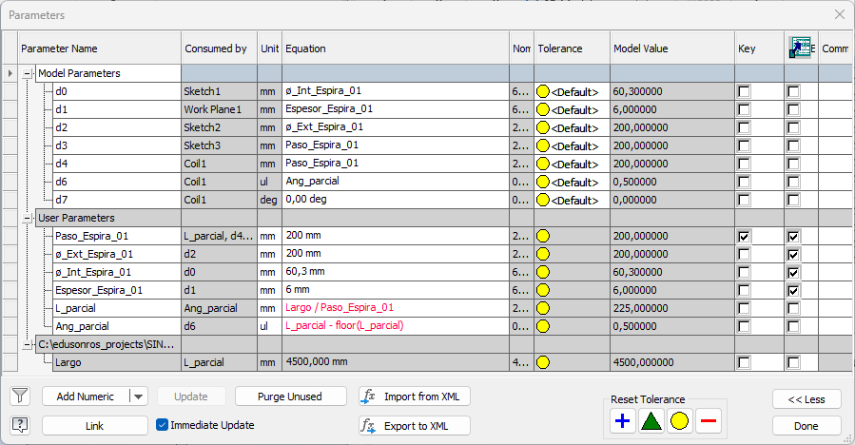

Y por fin el dibujo “Espira_01.idw”, conlas reglas iLogic:
'========================================
' 01_Actualizar_Plano
' Actualiza el plano activo (y fuerza regen)
'========================================

Try
Dim oDoc As Inventor.DrawingDocument = ThisApplication.ActiveDocument

' Actualiza el documento
oDoc.Update()

' Fuerza actualización “fuerte” (si está disponible)
Try
ThisApplication.ActiveDocument.Update2(True)
Catch
' Algunas versiones/estados no soportan Update2 aquí, no pasa nada
End Try

Catch ex As Exception
MessageBox.Show("Error al actualizar el plano: " & ex.Message, "iLogic")
End Try
, y la otra: '========================================
' 02_Exportar_PDF
' Exporta el plano activo a PDF (robusto)
'========================================

Function TryGetParamMM(ByVal refDoc As Inventor.Document, ByVal pName As String, ByVal ByRef valOut As Double) As Boolean
Try
Dim p As Inventor.Parameter = refDoc.ComponentDefinition.Parameters.Item(pName)
' Value está en cm en algunos contextos? En Inventor API suele estar en cm (dependiendo). Aquí asumimos unidades internas.
' Mejor: usar .Value y luego pasar a mm con UnitsOfMeasure.
Dim uom = refDoc.UnitsOfMeasure
valOut = uom.ConvertUnits(p.Value, uom.LengthUnits, Inventor.UnitsTypeEnum.kMillimeterLengthUnits)
Return True
Catch
Return False
End Try
End Function

Function TryGetParamUnitless(ByVal refDoc As Inventor.Document, ByVal pName As String, ByVal ByRef valOut As Double) As Boolean
Try
Dim p As Inventor.Parameter = refDoc.ComponentDefinition.Parameters.Item(pName)
valOut = p.Value
Return True
Catch
Return False
End Try
End Function

Try
Dim oDoc As Inventor.DrawingDocument = ThisApplication.ActiveDocument

'--- Carpeta destino
Dim outFolder As String = "C:\edusonros_projects\SINFINES_CONRAD\PDF\"
If Not System.IO.Directory.Exists(outFolder) Then
System.IO.Directory.CreateDirectory(outFolder)
End If

'--- Referenciado principal (mejor desde la primera vista del Sheet1 si existe)
Dim refDoc As Inventor.Document = Nothing
Try
Dim oSheet As Inventor.Sheet = oDoc.Sheets.Item(1)
If oSheet.DrawingViews.Count > 0 Then
refDoc = oSheet.DrawingViews.Item(1).ReferencedDocumentDescriptor.ReferencedDocument
End If
Catch
' fallback
End Try

If refDoc Is Nothing Then
' fallback: primer documento referenciado
refDoc = oDoc.ReferencedDocuments.Item(1)
End If

'--- Construir nombre PDF
Dim baseName As String = System.IO.Path.GetFileNameWithoutExtension(oDoc.FullFileName)

' Intenta leer parámetros habituales
Dim L As Double, DE As Double, DI As Double, E As Double, P As Double, N As Double
Dim hasL As Boolean = TryGetParamMM(refDoc, "Largo", L)
Dim hasDE As Boolean = TryGetParamMM(refDoc, "DiametroExterior", DE)
Dim hasDI As Boolean = TryGetParamMM(refDoc, "DiametroInterior", DI)
Dim hasE As Boolean = TryGetParamMM(refDoc, "Espesor", E)
Dim hasP As Boolean = TryGetParamMM(refDoc, "Paso_Espira_01", P) OrElse TryGetParamMM(refDoc, "Paso_Espira", P) OrElse TryGetParamMM(refDoc, "Paso_Esp", P)
Dim hasN As Boolean = TryGetParamUnitless(refDoc, "Num_Espiras", N) OrElse TryGetParamUnitless(refDoc, "Num_Vueltas", N)

Dim pdfName As String = baseName & ".pdf"

' Si hay datos, los metemos en el nombre
If hasL Or hasDE Or hasE Or hasP Or hasN Then
Dim parts As New List(Of String)

If hasDE Then parts.Add("DE" & CInt(Math.Round(DE)))
If hasDI Then parts.Add("DI" & CInt(Math.Round(DI)))
If hasE Then parts.Add("E" & CInt(Math.Round(E)))
If hasL Then parts.Add("L" & CInt(Math.Round(L)))
If hasP Then parts.Add("P" & CInt(Math.Round(P)))
If hasN Then parts.Add("N" & CInt(Math.Round(N)))

pdfName = baseName & "_" & String.Join("_", parts.ToArray()) & ".pdf"
End If

Dim pdfPath As String = System.IO.Path.Combine(outFolder, pdfName)

If System.IO.File.Exists(pdfPath) Then
Dim ts As String = DateTime.Now.ToString("yyyyMMdd_HHmmss")
pdfPath = System.IO.Path.Combine(outFolder, System.IO.Path.GetFileNameWithoutExtension(pdfName) & "_" & ts & ".pdf")
End If

'--- Actualizar antes de exportar
oDoc.Update()

'--- Traductor PDF
Dim oPDFAddIn As Inventor.ApplicationAddIn =
ThisApplication.ApplicationAddIns.ItemById("{0AC6FD96-2F4D-42CE-8BE0-8AEA580399E4}")

Dim oContext As Inventor.TranslationContext =
ThisApplication.TransientObjects.CreateTranslationContext()
oContext.Type = Inventor.IOMechanismEnum.kFileBrowseIOMechanism

Dim oOptions As Inventor.NameValueMap =
ThisApplication.TransientObjects.CreateNameValueMap()

If oPDFAddIn.HasSaveCopyAsOptions(oDoc, oContext, oOptions) Then
oOptions.Value("All_Color_AS_Black") = 1
oOptions.Value("Remove_Line_Weights") = 0
oOptions.Value("Vector_Resolution") = 400
oOptions.Value("Sheet_Range") = Inventor.PrintRangeEnum.kPrintAllSheets
End If

Dim oData As Inventor.DataMedium =
ThisApplication.TransientObjects.CreateDataMedium()
oData.FileName = pdfPath

oPDFAddIn.SaveCopyAs(oDoc, oContext, oOptions, oData)

Catch ex As Exception
MessageBox.Show("Error exportando PDF: " & ex.Message, "iLogic PDF")
End Try

L que nos da:

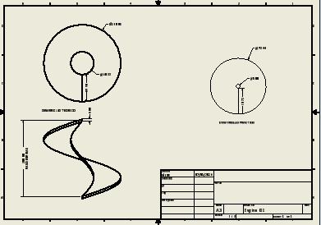

Despues tenemos el archivo “Mangon_Conduccion.ipt” que tiene las variables siguientes:
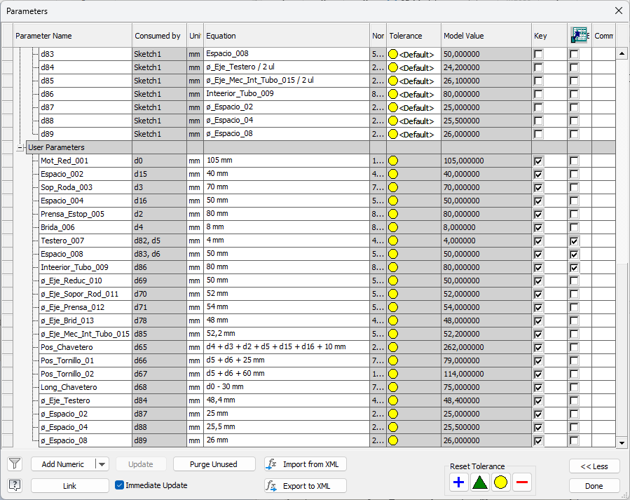
Que va con el archivo de dibujo “Mangon_Conduccion.idw”, con los programas iLogic:
'========================================
' 01_Actualizar_Plano
' Actualiza el plano activo (y fuerza regen)

'========================================

Try
Dim oDoc As Inventor.DrawingDocument = ThisApplication.ActiveDocument

' Actualiza el documento
oDoc.Update()

' Fuerza actualización “fuerte” (si está disponible)
Try
ThisApplication.ActiveDocument.Update2(True)
Catch
' Algunas versiones/estados no soportan Update2 aquí, no pasa nada
End Try

Catch ex As Exception
MessageBox.Show("Error al actualizar el plano: " & ex.Message, "iLogic")
End Try

Y la regla:
'========================================
' 02_Exportar_PDF
' Exporta el plano activo a PDF (robusto)
'========================================

Function TryGetParamMM(ByVal refDoc As Inventor.Document, ByVal pName As String, ByVal ByRef valOut As Double) As Boolean
Try
Dim p As Inventor.Parameter = refDoc.ComponentDefinition.Parameters.Item(pName)
' Value está en cm en algunos contextos? En Inventor API suele estar en cm (dependiendo). Aquí asumimos unidades internas.
' Mejor: usar .Value y luego pasar a mm con UnitsOfMeasure.
Dim uom = refDoc.UnitsOfMeasure
valOut = uom.ConvertUnits(p.Value, uom.LengthUnits, Inventor.UnitsTypeEnum.kMillimeterLengthUnits)
Return True
Catch
Return False
End Try
End Function

Function TryGetParamUnitless(ByVal refDoc As Inventor.Document, ByVal pName As String, ByVal ByRef valOut As Double) As Boolean
Try
Dim p As Inventor.Parameter = refDoc.ComponentDefinition.Parameters.Item(pName)
valOut = p.Value
Return True
Catch
Return False
End Try
End Function

Try
Dim oDoc As Inventor.DrawingDocument = ThisApplication.ActiveDocument

'--- Carpeta destino
Dim outFolder As String = "C:\edusonros_projects\SINFINES_CONRAD\PDF\"
If Not System.IO.Directory.Exists(outFolder) Then
System.IO.Directory.CreateDirectory(outFolder)
End If

'--- Referenciado principal (mejor desde la primera vista del Sheet1 si existe)
Dim refDoc As Inventor.Document = Nothing
Try
Dim oSheet As Inventor.Sheet = oDoc.Sheets.Item(1)
If oSheet.DrawingViews.Count > 0 Then
refDoc = oSheet.DrawingViews.Item(1).ReferencedDocumentDescriptor.ReferencedDocument
End If
Catch
' fallback
End Try

If refDoc Is Nothing Then
' fallback: primer documento referenciado
refDoc = oDoc.ReferencedDocuments.Item(1)
End If

'--- Construir nombre PDF
Dim baseName As String = System.IO.Path.GetFileNameWithoutExtension(oDoc.FullFileName)

' Intenta leer parámetros habituales
Dim L As Double, DE As Double, DI As Double, E As Double, P As Double, N As Double
Dim hasL As Boolean = TryGetParamMM(refDoc, "Largo", L)
Dim hasDE As Boolean = TryGetParamMM(refDoc, "DiametroExterior", DE)
Dim hasDI As Boolean = TryGetParamMM(refDoc, "DiametroInterior", DI)
Dim hasE As Boolean = TryGetParamMM(refDoc, "Espesor", E)
Dim hasP As Boolean = TryGetParamMM(refDoc, "Paso_Espira_01", P) OrElse TryGetParamMM(refDoc, "Paso_Espira", P) OrElse TryGetParamMM(refDoc, "Paso_Esp", P)
Dim hasN As Boolean = TryGetParamUnitless(refDoc, "Num_Espiras", N) OrElse TryGetParamUnitless(refDoc, "Num_Vueltas", N)

Dim pdfName As String = baseName & ".pdf"

' Si hay datos, los metemos en el nombre
If hasL Or hasDE Or hasE Or hasP Or hasN Then
Dim parts As New List(Of String)

If hasDE Then parts.Add("DE" & CInt(Math.Round(DE)))
If hasDI Then parts.Add("DI" & CInt(Math.Round(DI)))
If hasE Then parts.Add("E" & CInt(Math.Round(E)))
If hasL Then parts.Add("L" & CInt(Math.Round(L)))
If hasP Then parts.Add("P" & CInt(Math.Round(P)))
If hasN Then parts.Add("N" & CInt(Math.Round(N)))

pdfName = baseName & "_" & String.Join("_", parts.ToArray()) & ".pdf"
End If

Dim pdfPath As String = System.IO.Path.Combine(outFolder, pdfName)

If System.IO.File.Exists(pdfPath) Then
Dim ts As String = DateTime.Now.ToString("yyyyMMdd_HHmmss")
pdfPath = System.IO.Path.Combine(outFolder, System.IO.Path.GetFileNameWithoutExtension(pdfName) & "_" & ts & ".pdf")
End If

'--- Actualizar antes de exportar
oDoc.Update()

'--- Traductor PDF
Dim oPDFAddIn As Inventor.ApplicationAddIn =
ThisApplication.ApplicationAddIns.ItemById("{0AC6FD96-2F4D-42CE-8BE0-8AEA580399E4}")

Dim oContext As Inventor.TranslationContext =
ThisApplication.TransientObjects.CreateTranslationContext()
oContext.Type = Inventor.IOMechanismEnum.kFileBrowseIOMechanism

Dim oOptions As Inventor.NameValueMap =
ThisApplication.TransientObjects.CreateNameValueMap()

If oPDFAddIn.HasSaveCopyAsOptions(oDoc, oContext, oOptions) Then
oOptions.Value("All_Color_AS_Black") = 1
oOptions.Value("Remove_Line_Weights") = 0
oOptions.Value("Vector_Resolution") = 400
oOptions.Value("Sheet_Range") = Inventor.PrintRangeEnum.kPrintAllSheets
End If

Dim oData As Inventor.DataMedium =
ThisApplication.TransientObjects.CreateDataMedium()
oData.FileName = pdfPath

oPDFAddIn.SaveCopyAs(oDoc, oContext, oOptions, oData)

Catch ex As Exception
MessageBox.Show("Error exportando PDF: " & ex.Message, "iLogic PDF")
End Try
Lo que nos da: 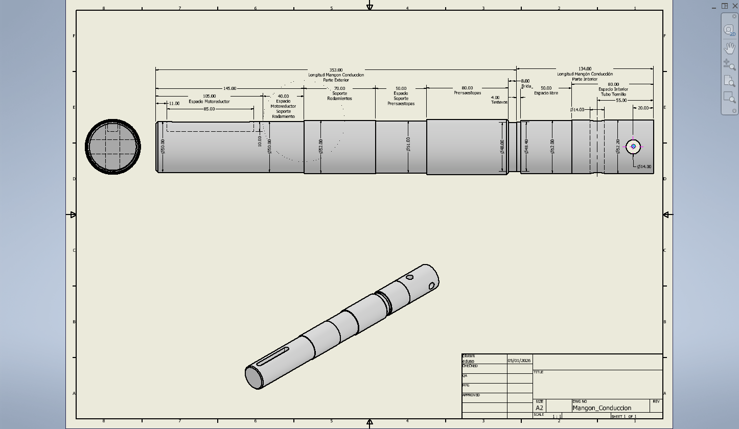

Penultimo, tenemos “Mangon_Conducido.ipt” con las variables:
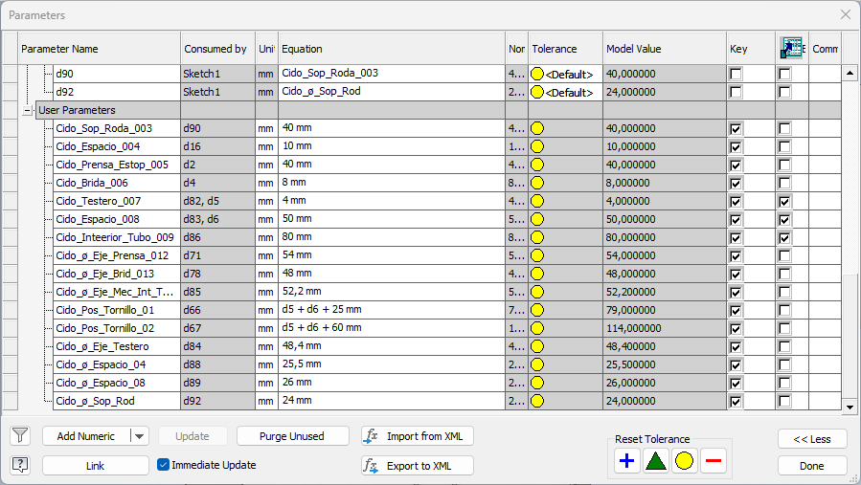
Con su “Mangon_Conducido.idw”, con las reglas:
'========================================
' 01_Actualizar_Plano
' Actualiza el plano activo (y fuerza regen)
'========================================

Try
Dim oDoc As Inventor.DrawingDocument = ThisApplication.ActiveDocument

' Actualiza el documento
oDoc.Update()

' Fuerza actualización “fuerte” (si está disponible)
Try
ThisApplication.ActiveDocument.Update2(True)
Catch
' Algunas versiones/estados no soportan Update2 aquí, no pasa nada
End Try

'========================================
' 02_Exportar_PDF
' Exporta el plano activo a PDF (robusto)
'========================================

Function TryGetParamMM(ByVal refDoc As Inventor.Document, ByVal pName As String, ByVal ByRef valOut As Double) As Boolean
Try
Dim p As Inventor.Parameter = refDoc.ComponentDefinition.Parameters.Item(pName)
' Value está en cm en algunos contextos? En Inventor API suele estar en cm (dependiendo). Aquí asumimos unidades internas.
' Mejor: usar .Value y luego pasar a mm con UnitsOfMeasure.
Dim uom = refDoc.UnitsOfMeasure
valOut = uom.ConvertUnits(p.Value, uom.LengthUnits, Inventor.UnitsTypeEnum.kMillimeterLengthUnits)
Return True
Catch
Return False
End Try
End Function

Function TryGetParamUnitless(ByVal refDoc As Inventor.Document, ByVal pName As String, ByVal ByRef valOut As Double) As Boolean
Try
Dim p As Inventor.Parameter = refDoc.ComponentDefinition.Parameters.Item(pName)
valOut = p.Value
Return True
Catch
Return False
End Try
End Function

Try
Dim oDoc As Inventor.DrawingDocument = ThisApplication.ActiveDocument

'--- Carpeta destino
Dim outFolder As String = "C:\edusonros_projects\SINFINES_CONRAD\PDF\"
If Not System.IO.Directory.Exists(outFolder) Then
System.IO.Directory.CreateDirectory(outFolder)
End If

'--- Referenciado principal (mejor desde la primera vista del Sheet1 si existe)
Dim refDoc As Inventor.Document = Nothing
Try
Dim oSheet As Inventor.Sheet = oDoc.Sheets.Item(1)
If oSheet.DrawingViews.Count > 0 Then
refDoc = oSheet.DrawingViews.Item(1).ReferencedDocumentDescriptor.ReferencedDocument
End If
Catch
' fallback
End Try

If refDoc Is Nothing Then
' fallback: primer documento referenciado
refDoc = oDoc.ReferencedDocuments.Item(1)
End If

'--- Construir nombre PDF
Dim baseName As String = System.IO.Path.GetFileNameWithoutExtension(oDoc.FullFileName)

' Intenta leer parámetros habituales
Dim L As Double, DE As Double, DI As Double, E As Double, P As Double, N As Double
Dim hasL As Boolean = TryGetParamMM(refDoc, "Largo", L)
Dim hasDE As Boolean = TryGetParamMM(refDoc, "DiametroExterior", DE)
Dim hasDI As Boolean = TryGetParamMM(refDoc, "DiametroInterior", DI)
Dim hasE As Boolean = TryGetParamMM(refDoc, "Espesor", E)
Dim hasP As Boolean = TryGetParamMM(refDoc, "Paso_Espira_01", P) OrElse TryGetParamMM(refDoc, "Paso_Espira", P) OrElse TryGetParamMM(refDoc, "Paso_Esp", P)
Dim hasN As Boolean = TryGetParamUnitless(refDoc, "Num_Espiras", N) OrElse TryGetParamUnitless(refDoc, "Num_Vueltas", N)

Dim pdfName As String = baseName & ".pdf"

' Si hay datos, los metemos en el nombre
If hasL Or hasDE Or hasE Or hasP Or hasN Then
Dim parts As New List(Of String)

If hasDE Then parts.Add("DE" & CInt(Math.Round(DE)))
If hasDI Then parts.Add("DI" & CInt(Math.Round(DI)))
If hasE Then parts.Add("E" & CInt(Math.Round(E)))
If hasL Then parts.Add("L" & CInt(Math.Round(L)))
If hasP Then parts.Add("P" & CInt(Math.Round(P)))
If hasN Then parts.Add("N" & CInt(Math.Round(N)))

pdfName = baseName & "_" & String.Join("_", parts.ToArray()) & ".pdf"
End If

Dim pdfPath As String = System.IO.Path.Combine(outFolder, pdfName)

If System.IO.File.Exists(pdfPath) Then
Dim ts As String = DateTime.Now.ToString("yyyyMMdd_HHmmss")
pdfPath = System.IO.Path.Combine(outFolder, System.IO.Path.GetFileNameWithoutExtension(pdfName) & "_" & ts & ".pdf")
End If

'--- Actualizar antes de exportar
oDoc.Update()

'--- Traductor PDF
Dim oPDFAddIn As Inventor.ApplicationAddIn =
ThisApplication.ApplicationAddIns.ItemById("{0AC6FD96-2F4D-42CE-8BE0-8AEA580399E4}")

Dim oContext As Inventor.TranslationContext =
ThisApplication.TransientObjects.CreateTranslationContext()
oContext.Type = Inventor.IOMechanismEnum.kFileBrowseIOMechanism

Dim oOptions As Inventor.NameValueMap =
ThisApplication.TransientObjects.CreateNameValueMap()

If oPDFAddIn.HasSaveCopyAsOptions(oDoc, oContext, oOptions) Then
oOptions.Value("All_Color_AS_Black") = 1
oOptions.Value("Remove_Line_Weights") = 0
oOptions.Value("Vector_Resolution") = 400
oOptions.Value("Sheet_Range") = Inventor.PrintRangeEnum.kPrintAllSheets
End If

Dim oData As Inventor.DataMedium =
ThisApplication.TransientObjects.CreateDataMedium()
oData.FileName = pdfPath

oPDFAddIn.SaveCopyAs(oDoc, oContext, oOptions, oData)

Catch ex As Exception
MessageBox.Show("Error exportando PDF: " & ex.Message, "iLogic PDF")
End Try

Lo que nos da:
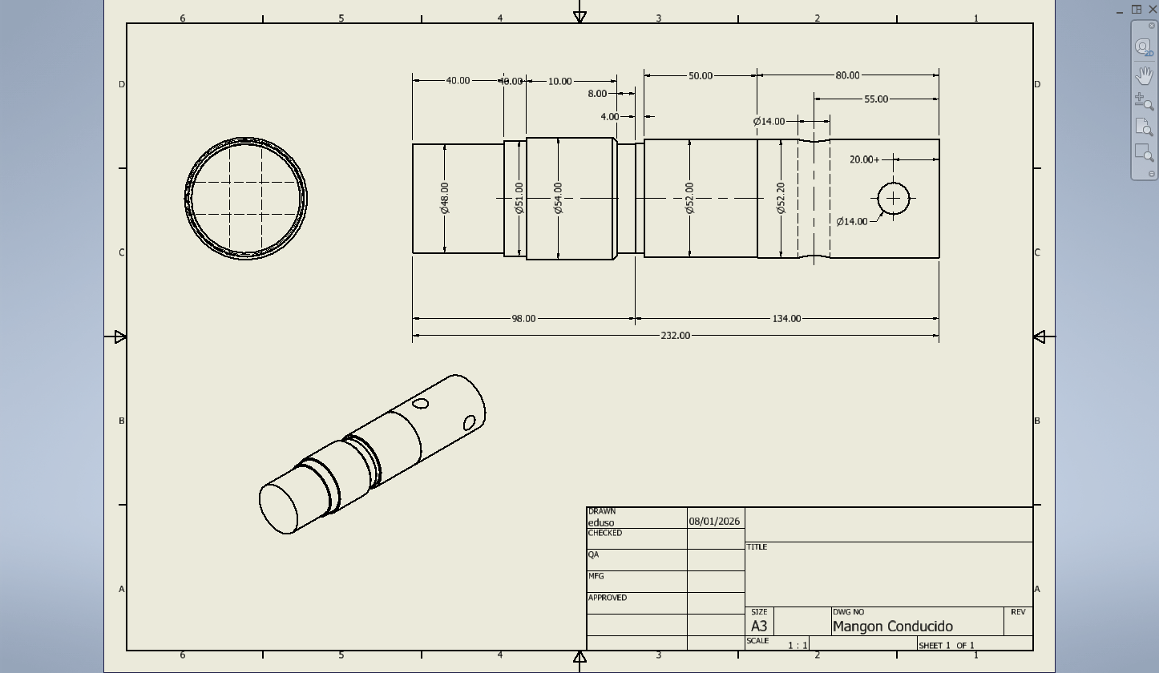

Y por ultimo tenemos en subconjunto “Tornillo+Tuerca M12x90.iam”, que es la representación del conjunto de un tornillo m12x90 mas dos arandelas + tuerca de cierre.
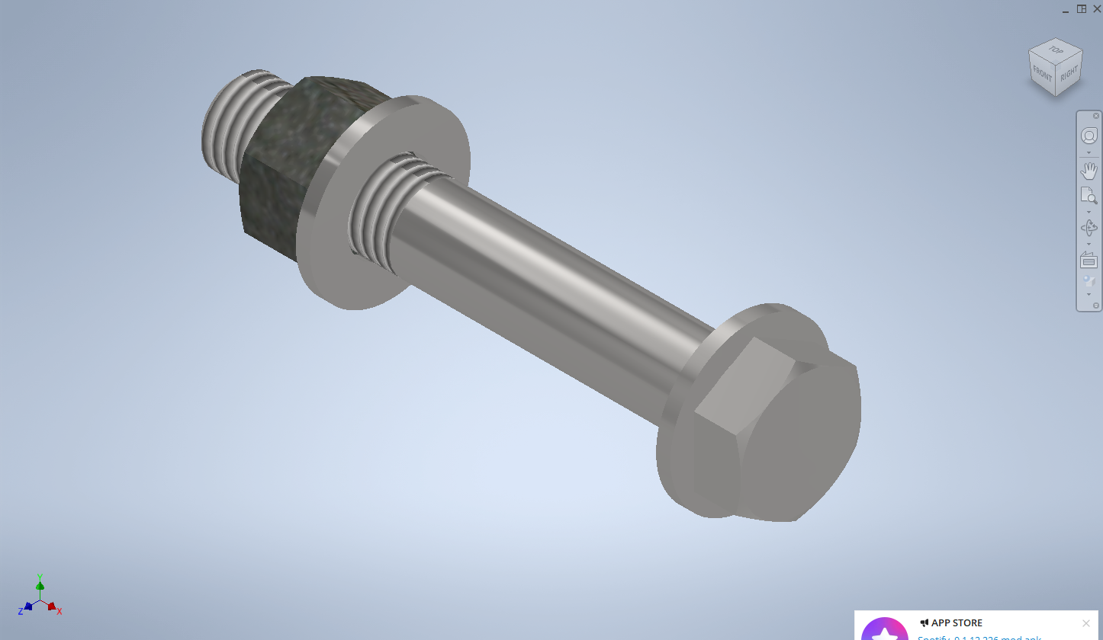

Finalmente, todas estas piezas se ensamblan en el conjunto “Tornillo_Sinfin_v001.iam”
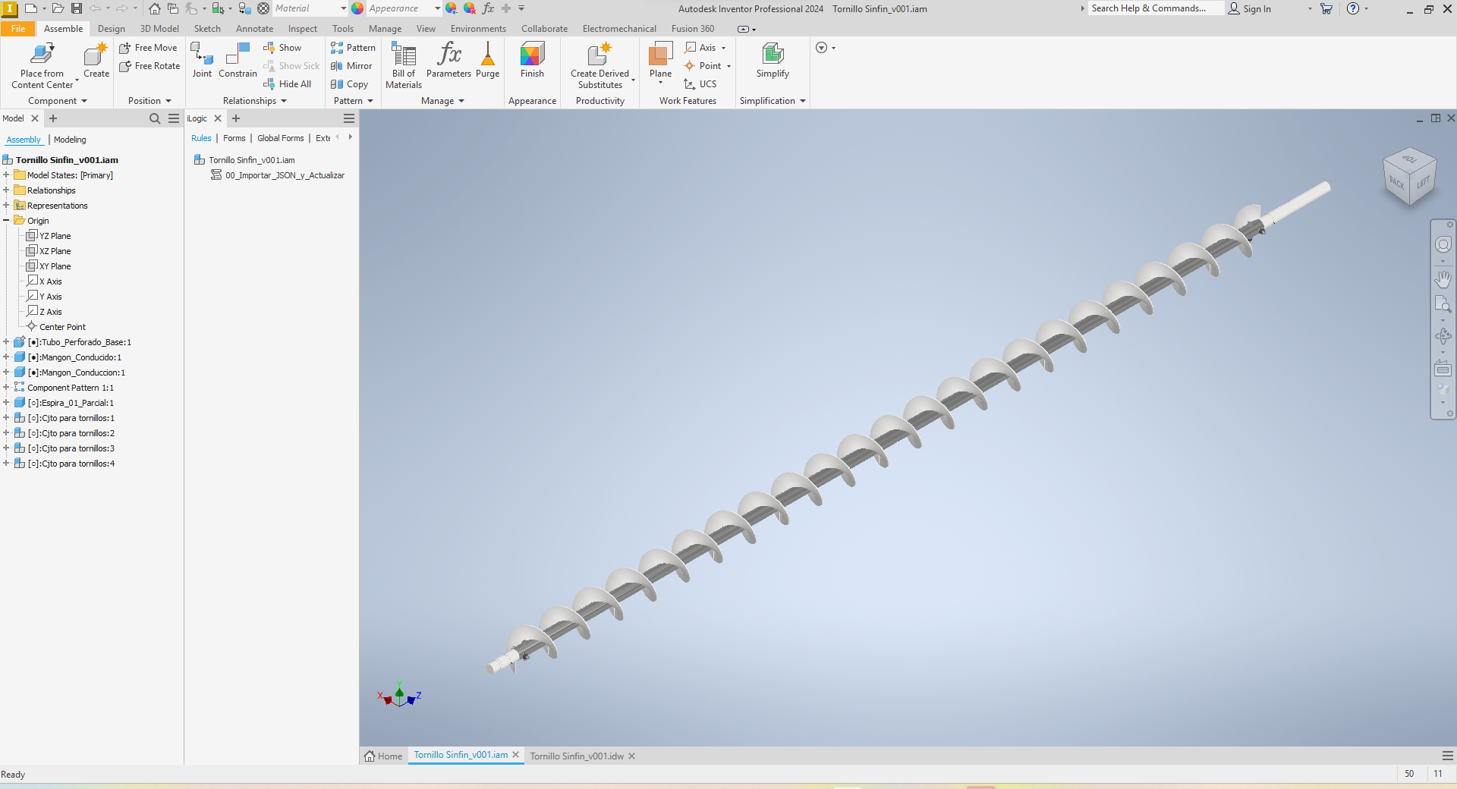
Con la variables:
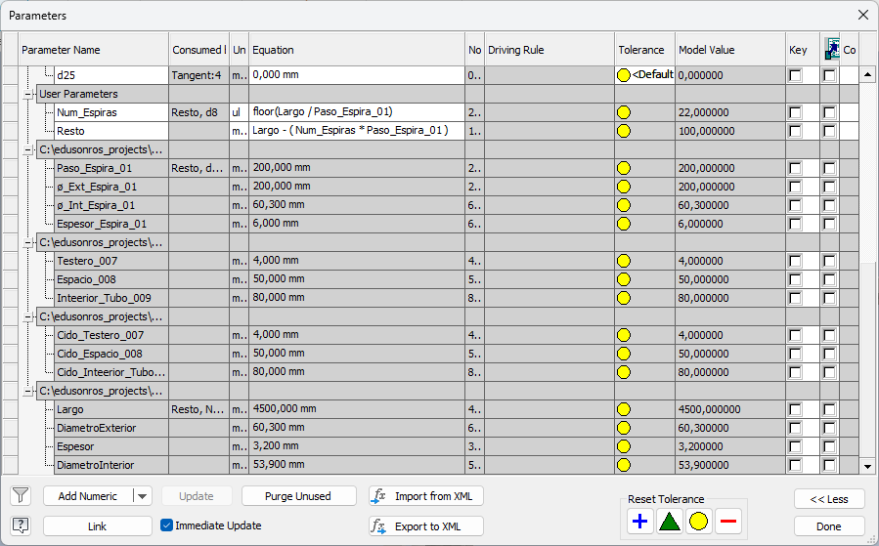

El cual contiene la regla IiLogic, NO probada:
Imports System.IO
Imports System.Web.Script.Serialization
'========================================
' 00_Importar_JSON_y_Actualizar
' Lee un JSON genérico (Parametro:Valor en mm)
' y lo aplica por nombre a: IAM + IPTs referenciados.
'========================================

Sub Main()

Dim jsonPath As String = "C:\edusonros_projects\SINFINES_CONRAD\cfg\tornillo_001.json"
If Not File.Exists(jsonPath) Then
MessageBox.Show("No existe el JSON: " & jsonPath, "iLogic")
Exit Sub
End If

'--- Leer JSON
Dim txt As String = File.ReadAllText(jsonPath)
Dim ser As New JavaScriptSerializer()
Dim root = ser.DeserializeObject(txt)

' root("global") -> Dictionary
Dim globals As Object = Nothing
Try
globals = DirectCast(root, Dictionary(Of String, Object))("global")
Catch
MessageBox.Show("JSON sin nodo 'global'.", "iLogic")
Exit Sub
End Try

Dim dict = DirectCast(globals, Dictionary(Of String, Object))

'--- 1) Aplicar al propio IAM (si existen parámetros con ese nombre)
ApplyDictToDocParams(ThisDoc.Document, dict)

'--- 2) Aplicar a todos los documentos referenciados (IPTs/IAMs)
' OJO: si un parámetro no existe en un IPT, se ignora sin romper.
Dim oAsm As AssemblyDocument = ThisDoc.Document
For Each refDoc As Document In oAsm.AllReferencedDocuments
If refDoc.DocumentType = DocumentTypeEnum.kPartDocumentObject _
Or refDoc.DocumentType = DocumentTypeEnum.kAssemblyDocumentObject Then

ApplyDictToDocParams(refDoc, dict)

Try
refDoc.Update()
refDoc.Save2(True)
Catch
'silencio: si está read-only o no procede
End Try
End If
Next

'--- Update del IAM al final
ThisDoc.Document.Update()
ThisDoc.Document.Save2(True)

MessageBox.Show("Parámetros aplicados y documentos actualizados.", "iLogic")

End Sub

Private Sub ApplyDictToDocParams(doc As Document, dict As Dictionary(Of String, Object))

Dim params As Parameters = Nothing
Try
If doc.DocumentType = DocumentTypeEnum.kPartDocumentObject Then
params = DirectCast(doc, PartDocument).ComponentDefinition.Parameters
ElseIf doc.DocumentType = DocumentTypeEnum.kAssemblyDocumentObject Then
params = DirectCast(doc, AssemblyDocument).ComponentDefinition.Parameters
Else
Exit Sub
End If
Catch
Exit Sub
End Try

For Each kvp In dict
Dim pName As String = kvp.Key
Dim pValObj As Object = kvp.Value

' Convertir a Double
Dim v As Double
Try
v = CDbl(pValObj)
Catch
Continue For
End Try

' Intentar: UserParameter primero, si no, cualquier parámetro
Dim p As Parameter = Nothing

Try
p = params.UserParameters.Item(pName)
Catch
Try
p = params.Item(pName)
Catch
p = Nothing
End Try
End Try

If p Is Nothing Then Continue For

Try
' Si es longitud: meter "mm". Si es unitless, meter número.
If p.Units = "mm" Or p.Units = "cm" Or p.Units = "m" Then
p.Expression = v.ToString(System.Globalization.CultureInfo.InvariantCulture) & " mm"
ElseIf p.Units = "deg" Then
p.Expression = v.ToString(System.Globalization.CultureInfo.InvariantCulture) & " deg"
Else
p.Expression = v.ToString(System.Globalization.CultureInfo.InvariantCulture)
End If
Catch
'Si está bloqueado por fórmula, ignora
End Try
Next

End Sub

Que nos da:
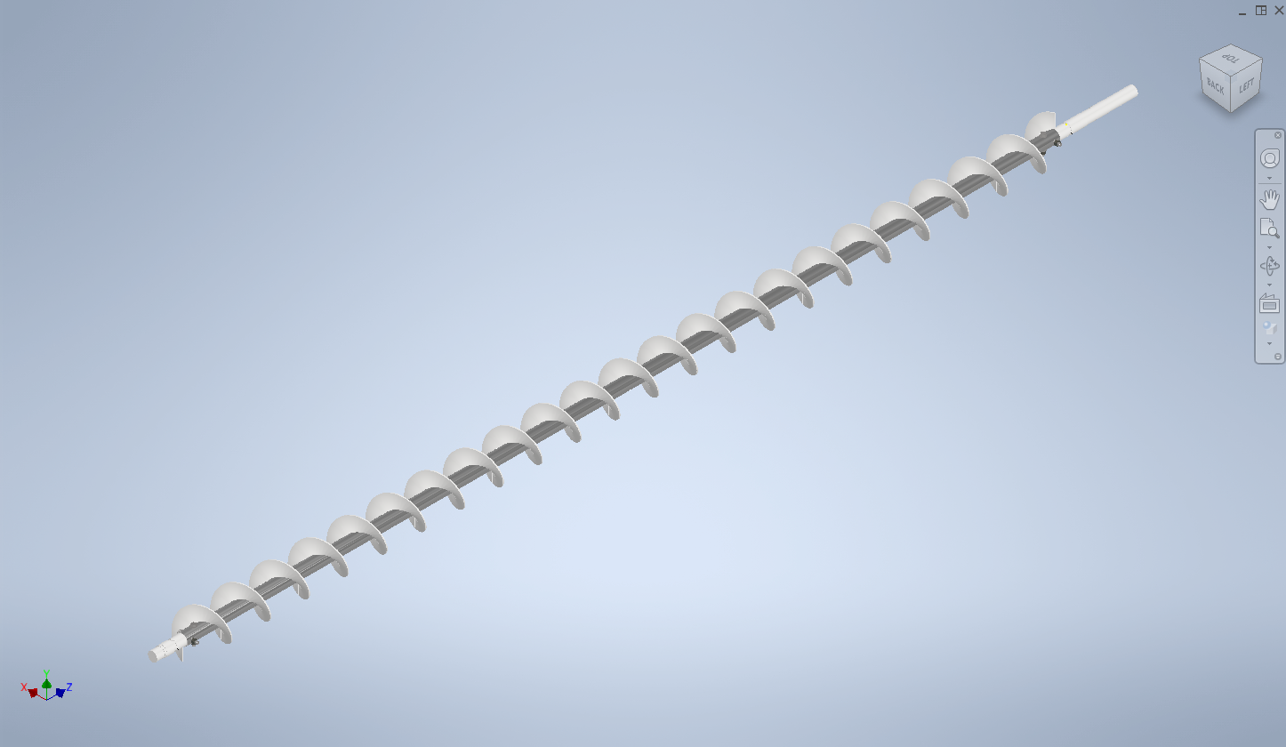
Y con su idw:
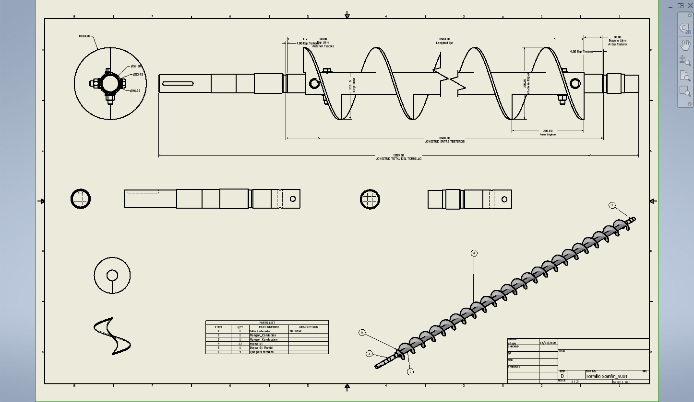

Que contiene las reglas:
'========================================
' 01_Actualizar_Plano
' Actualiza el plano activo (y fuerza regen)
'========================================

Try
Dim oDoc As Inventor.DrawingDocument = ThisApplication.ActiveDocument

' Actualiza el documento
oDoc.Update()

' Fuerza actualización “fuerte” (si está disponible)
Try
ThisApplication.ActiveDocument.Update2(True)
Catch
' Algunas versiones/estados no soportan Update2 aquí, no pasa nada
End Try

Catch ex As Exception
MessageBox.Show("Error al actualizar el plano: " & ex.Message, "iLogic")
End Try

'========================================
' 02_Exportar_PDF
' Exporta el plano activo a PDF (robusto)
'========================================

Function TryGetParamMM(ByVal refDoc As Inventor.Document, ByVal pName As String, ByVal ByRef valOut As Double) As Boolean
Try
Dim p As Inventor.Parameter = refDoc.ComponentDefinition.Parameters.Item(pName)
' Value está en cm en algunos contextos? En Inventor API suele estar en cm (dependiendo). Aquí asumimos unidades internas.
' Mejor: usar .Value y luego pasar a mm con UnitsOfMeasure.
Dim uom = refDoc.UnitsOfMeasure
valOut = uom.ConvertUnits(p.Value, uom.LengthUnits, Inventor.UnitsTypeEnum.kMillimeterLengthUnits)
Return True
Catch
Return False
End Try
End Function

Function TryGetParamUnitless(ByVal refDoc As Inventor.Document, ByVal pName As String, ByVal ByRef valOut As Double) As Boolean
Try
Dim p As Inventor.Parameter = refDoc.ComponentDefinition.Parameters.Item(pName)
valOut = p.Value
Return True
Catch
Return False
End Try
End Function

Try
Dim oDoc As Inventor.DrawingDocument = ThisApplication.ActiveDocument

'--- Carpeta destino
Dim outFolder As String = "C:\edusonros_projects\SINFINES_CONRAD\PDF\"
If Not System.IO.Directory.Exists(outFolder) Then
System.IO.Directory.CreateDirectory(outFolder)
End If

'--- Referenciado principal (mejor desde la primera vista del Sheet1 si existe)
Dim refDoc As Inventor.Document = Nothing
Try
Dim oSheet As Inventor.Sheet = oDoc.Sheets.Item(1)
If oSheet.DrawingViews.Count > 0 Then
refDoc = oSheet.DrawingViews.Item(1).ReferencedDocumentDescriptor.ReferencedDocument
End If
Catch
' fallback
End Try

If refDoc Is Nothing Then
' fallback: primer documento referenciado
refDoc = oDoc.ReferencedDocuments.Item(1)
End If

'--- Construir nombre PDF
Dim baseName As String = System.IO.Path.GetFileNameWithoutExtension(oDoc.FullFileName)

' Intenta leer parámetros habituales
Dim L As Double, DE As Double, DI As Double, E As Double, P As Double, N As Double
Dim hasL As Boolean = TryGetParamMM(refDoc, "Largo", L)
Dim hasDE As Boolean = TryGetParamMM(refDoc, "DiametroExterior", DE)
Dim hasDI As Boolean = TryGetParamMM(refDoc, "DiametroInterior", DI)
Dim hasE As Boolean = TryGetParamMM(refDoc, "Espesor", E)
Dim hasP As Boolean = TryGetParamMM(refDoc, "Paso_Espira_01", P) OrElse TryGetParamMM(refDoc, "Paso_Espira", P) OrElse TryGetParamMM(refDoc, "Paso_Esp", P)
Dim hasN As Boolean = TryGetParamUnitless(refDoc, "Num_Espiras", N) OrElse TryGetParamUnitless(refDoc, "Num_Vueltas", N)

Dim pdfName As String = baseName & ".pdf"

' Si hay datos, los metemos en el nombre
If hasL Or hasDE Or hasE Or hasP Or hasN Then
Dim parts As New List(Of String)

If hasDE Then parts.Add("DE" & CInt(Math.Round(DE)))
If hasDI Then parts.Add("DI" & CInt(Math.Round(DI)))
If hasE Then parts.Add("E" & CInt(Math.Round(E)))
If hasL Then parts.Add("L" & CInt(Math.Round(L)))
If hasP Then parts.Add("P" & CInt(Math.Round(P)))
If hasN Then parts.Add("N" & CInt(Math.Round(N)))

pdfName = baseName & "_" & String.Join("_", parts.ToArray()) & ".pdf"
End If

Dim pdfPath As String = System.IO.Path.Combine(outFolder, pdfName)

If System.IO.File.Exists(pdfPath) Then
Dim ts As String = DateTime.Now.ToString("yyyyMMdd_HHmmss")
pdfPath = System.IO.Path.Combine(outFolder, System.IO.Path.GetFileNameWithoutExtension(pdfName) & "_" & ts & ".pdf")
End If

'--- Actualizar antes de exportar
oDoc.Update()

'--- Traductor PDF
Dim oPDFAddIn As Inventor.ApplicationAddIn =
ThisApplication.ApplicationAddIns.ItemById("{0AC6FD96-2F4D-42CE-8BE0-8AEA580399E4}")

Dim oContext As Inventor.TranslationContext =
ThisApplication.TransientObjects.CreateTranslationContext()
oContext.Type = Inventor.IOMechanismEnum.kFileBrowseIOMechanism

Dim oOptions As Inventor.NameValueMap =
ThisApplication.TransientObjects.CreateNameValueMap()

If oPDFAddIn.HasSaveCopyAsOptions(oDoc, oContext, oOptions) Then
oOptions.Value("All_Color_AS_Black") = 1
oOptions.Value("Remove_Line_Weights") = 0
oOptions.Value("Vector_Resolution") = 400
oOptions.Value("Sheet_Range") = Inventor.PrintRangeEnum.kPrintAllSheets
End If

Dim oData As Inventor.DataMedium =
ThisApplication.TransientObjects.CreateDataMedium()
oData.FileName = pdfPath

oPDFAddIn.SaveCopyAs(oDoc, oContext, oOptions, oData)

Catch ex As Exception
MessageBox.Show("Error exportando PDF: " & ex.Message, "iLogic PDF")
End Try

Y

Imports System.IO
DF'========================================
' 01_Exportar_TODO_PDF
' Exporta PDF del conjunto y de todas las piezas (si existe su IDW)
' ejecutando la regla "02_Exportar_PDF" dentro de cada IDW.
'========================================

Sub Main()

Dim outRoot As String = "C:\edusonros_projects\SINFINES_CONRAD\PDF\"
If Not Directory.Exists(outRoot) Then Directory.CreateDirectory(outRoot)

Dim asmDoc As AssemblyDocument = ThisDoc.Document

'--- 1) Exportar IDW del conjunto (mismo nombre que IAM)
Dim asmPath As String = asmDoc.FullFileName
Dim asmFolder As String = Path.GetDirectoryName(asmPath)
Dim asmNameNoExt As String = Path.GetFileNameWithoutExtension(asmPath)
Dim idwAsm As String = Path.Combine(asmFolder, asmNameNoExt & ".idw")

ExportIdwByRunningRule(idwAsm, "02_Exportar_PDF")

'--- 2) Exportar IDW de cada pieza si existe
For Each refDoc As Document In asmDoc.AllReferencedDocuments

If refDoc.DocumentType <> DocumentTypeEnum.kPartDocumentObject Then Continue For

Dim pPath As String = refDoc.FullFileName
If String.IsNullOrWhiteSpace(pPath) Then Continue For

Dim pFolder As String = Path.GetDirectoryName(pPath)
Dim pName As String = Path.GetFileNameWithoutExtension(pPath)

Dim idwPart As String = Path.Combine(pFolder, pName & ".idw")

ExportIdwByRunningRule(idwPart, "02_Exportar_PDF")
Next

MessageBox.Show("Exportación PDF finalizada (conjunto + piezas encontradas).", "iLogic")

End Sub

Private Sub ExportIdwByRunningRule(idwPath As String, ruleName As String)

If Not File.Exists(idwPath) Then
'No hay plano para esa pieza → lo saltamos
Exit Sub
End If

Dim oDoc As Document = Nothing

Try
oDoc = ThisApplication.Documents.Open(idwPath, True) 'True = Visible

Catch
Exit Sub
End Try

Try
' Ejecuta la regla que vive DENTRO de ese IDW
iLogicVb.RunRule(ruleName)
oDoc.Update()
oDoc.Save2(True)
Catch
'Si no existe la regla en ese IDW, no rompemos
Finally
Try
oDoc.Close(True)
Catch
End Try
End Try

End Sub

Ahora, con todos estos datos, y conociendo la lógica del programa Python que estamos programando, créame
Python genera params.csv → iLogic lo lee → actualiza modelo. además actualiza plano y exporta PDF/DWG/STEP.
Por ahora, vamos a empezar lanzando los valores que tenemos en los dibujos con los de la aplicación, a ver como se desarrolla el flujo.

